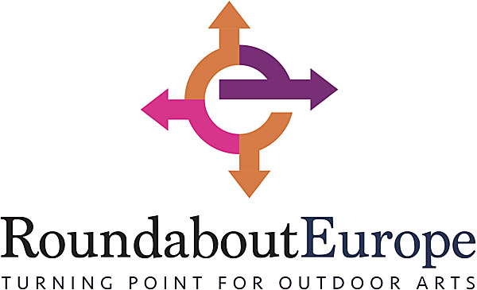

OPEN CALL - 4 November 2019
Roundabout Europe offers street artists residencies in two countries
Five outdoor arts festivals and five artists will collaborate again in Roundabout Europe 2020! Street artists based in countries eligible for Creative Europe may apply until 15 December 2019 for two residencies in two different countries in 2020.
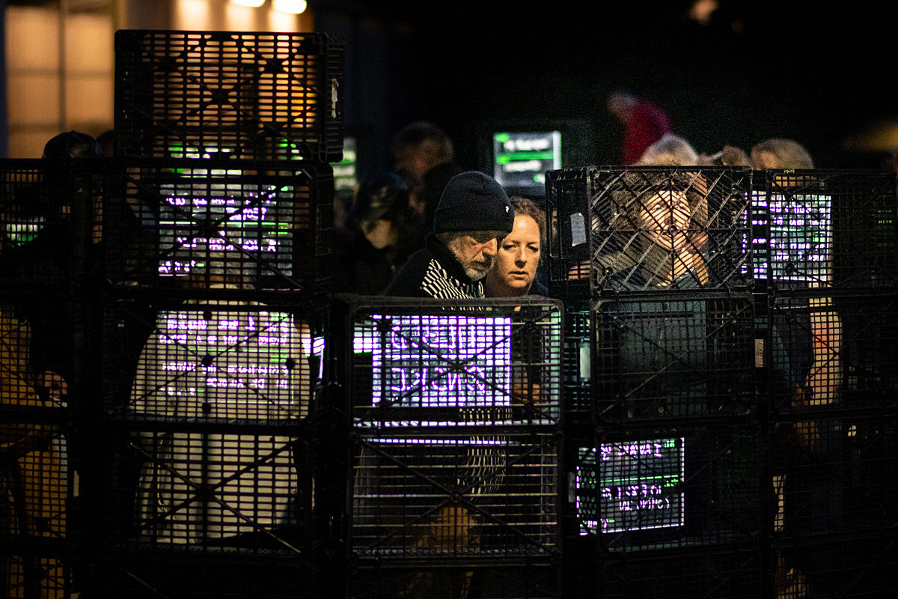
LUIT - Black Market during Passage 2019 (photo: Karsten Piper)

Roundabout Europe is building a European circuit of residencies and festivals of outdoor arts, targeting artistic companies that are either emerging or are at a turning point in their artistic development. The project has had a successful first edition. Five different artists or groups worked on a performance in different countries. Next year, five new artists have the chance to experience this wonderful opportunity.

Outdoor arts festivals
Roundabout Europe was created by five main partners who all are directors of respectable outdoor arts festivals from around Europe: Imaginarius from Portugal, KoresponDance festival from Czech Republic, Out There from the United Kingdom, Passage Festival from Denmark and Spoffin Festival from The Netherlands. Spoffin is the coordinator of the project.
They have teamed up with the aim of reinforcing capacity building of outdoor arts and making it well recognised art form that offers artistic companies a solid career and access to new audiences, networks and markets. Their goal is to empower artists to make their work more professional, self-critical, sustainable, economical and profitable without losing artistic values.

Workshops, coaching and inspiration
Each selected artist or artistic company is invited to do two residencies in different countries, and there will be a special focus, depending on their needs and wishes. Besides having time to work really focused on their performance, artists are offered several workshops and coaching sessions: practical, artistic and inspirational ones. The results of the residencies are presented at the festivals of the partners. Some will be full performances, others will be work in progresses.
It’s not only a residency, coaching and workshops they will receive: it’s also a great opportunity to find a new network from artists and professionals. Roundabout Europe makes sure the five selected artists are introduced to each other and are able to create their own new network. They will also be connected with the first five artists who entered Roundabout Europe. A great opportunity, both artistically as well as building a new network and audience.
"...I was lucky enough to spend the weekend with European colleagues (now friends) reflecting on the impact of an EU funded project on the artists and festivals that took part. Whatever happens beyond the election I know that I want the UK be part of an international community. I want to next generations to have the same opportunities I have had, to be able to move freely across borders and to be able to find friendship, inspiration and solidarity wherever they go. "
Vicky Amedume, Upswing (UK)

Applications open
Applications are now being accepted until the 15th December 2019 and
5 artists/artistic groups will be selected until the end of February 2020. The application process is online, you can apply via roundabouteurope.eu by filling out the application form here. The selection will be made by the artistic directors of the participating festivals.
Roundabout Europe is co-funded by the Creative Europe programme of the European Union.

Note to the Editor (not for publication):
- You can use our photo free of charge if you credit the photographer. Additional photos are availabe on request.
- If you do not want to receive our press releases anymore, let us know and we will stop it immediately.
- For more info you may contact Ingelise de Vries via communication@roundabouteurope.eu.
- Contact for Czechia, Slovakia, Poland and Hungary is Michaela Kessler, michaela.kessler@se-s-ta.cz, www.se-s-ta.cz

